Jai Jagannath

22 December 2025

07:51

* 1. Reached railway station at 4:05 am
  2. Start at 4:30 am Jai Jagannath
  3. 7:15 am 5 Masala dosa 1 idli voda just round off the price.
  4. Lunch order taken on 12pm
  5. 130 pm Nandyal station
  6. 3pm lunch. Drangged in by chikappa
  7. 630 uno till 830
  8. 730 dinner roti and curry
  9. Reached Bhubaneswar at 10am 23 December.
  10. Reached hotel at 1030 am
  11. Left hotel at 1230 to lingraj temple.
  12. Completed darshan at 220 pm
      1. Insert history and time line.
      2. Insert shikara story about it being bow rama broke and complete timeline of the shiv dhanush.
      3. Insert Sthala purana
      4. Insert other stories about lingraj.
  13. 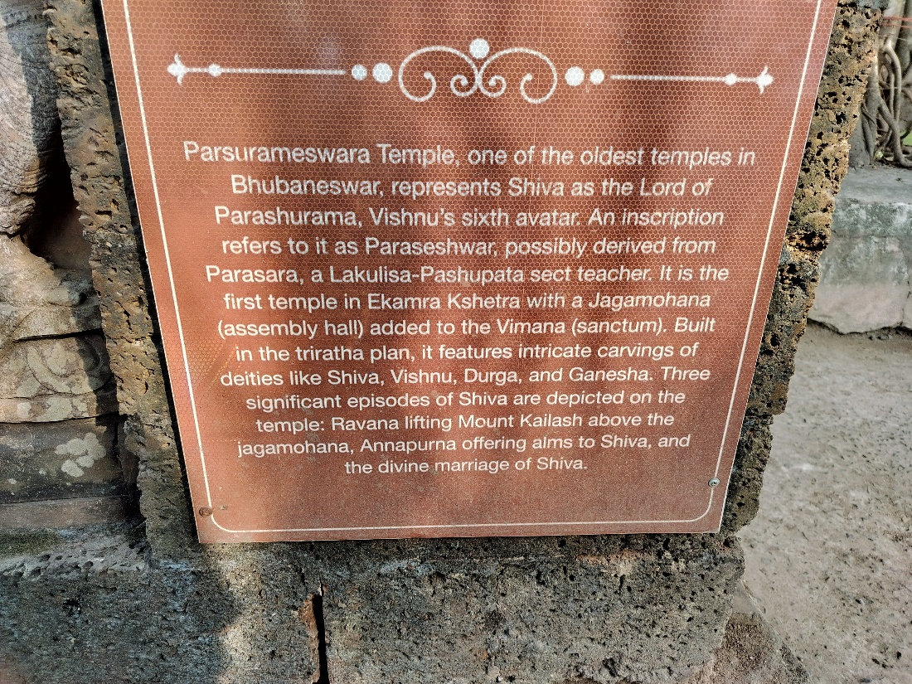
  14. Lunch at 330 at odisha tribal museum.
  15. Leaving musium at 430 on the way to kandagiri
  16. Kandagiri and udayagiri we made a mistake of of going to kandagiri first and then the the gates for udayagiri jain temple was closed we had to hop the fence run to the hill top and request the temple guard to allow us to do dharshan it was a beautiful digambar jain temple.
  17. Next week visited a beautiful ram mandir and there was satsang in progress there with chanting of ram nam.
  18. After that the driver dropped us near our hotel and we went for nearest sweet shop and started with dahi balla basikalli majjige vade, then the legendary chenna poda and then similar 3 other sweets, and then we moved out to find some thing spicy and we found papdi chat very good papdi chat and the guy used atleast atleast 30 ingredients and took 20 mins to prepare our chat it was the bomb.
  19. Then we went home at 845played rummy and uno till 1130 in the night.
  20. Morning of 24th we had awesome chole bature and left to cuttuk and jajpur.
  21. 10am ma cattack chandi shakti peetha. Insert stories
  22. 1030 netaji subhash chandra bose birth place. Insert stories
      1. 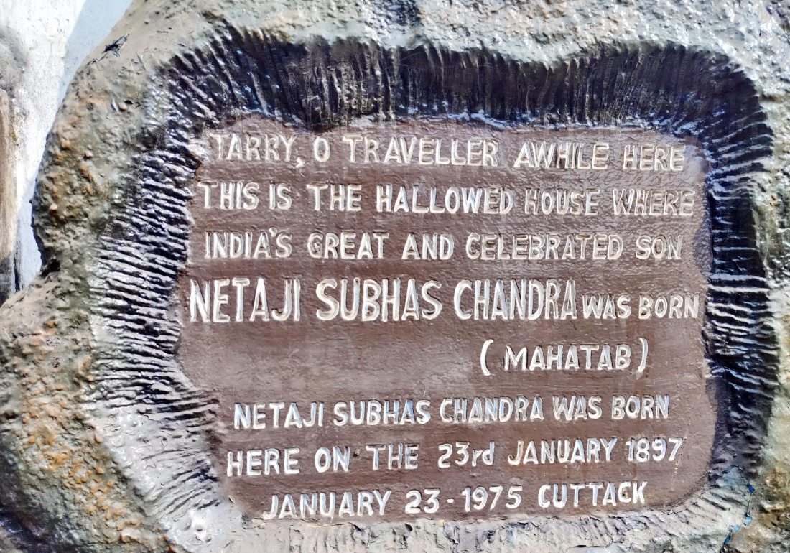

* 1. 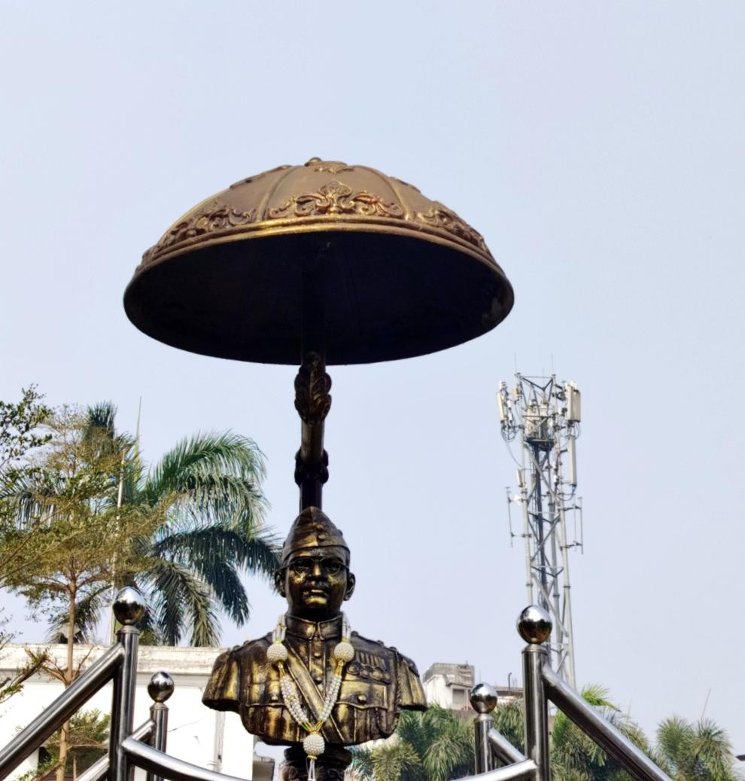
  2. Left at 1120. Insert stories
  3. On the way to Chhatia.
  4. We reached exactly at 12:58 and the door was about to close at 1 and we reached just in time and got a great darshan and right after darshan the doors closed. Insert Sthala purana of Maa biraja shakti peetha.
     1. 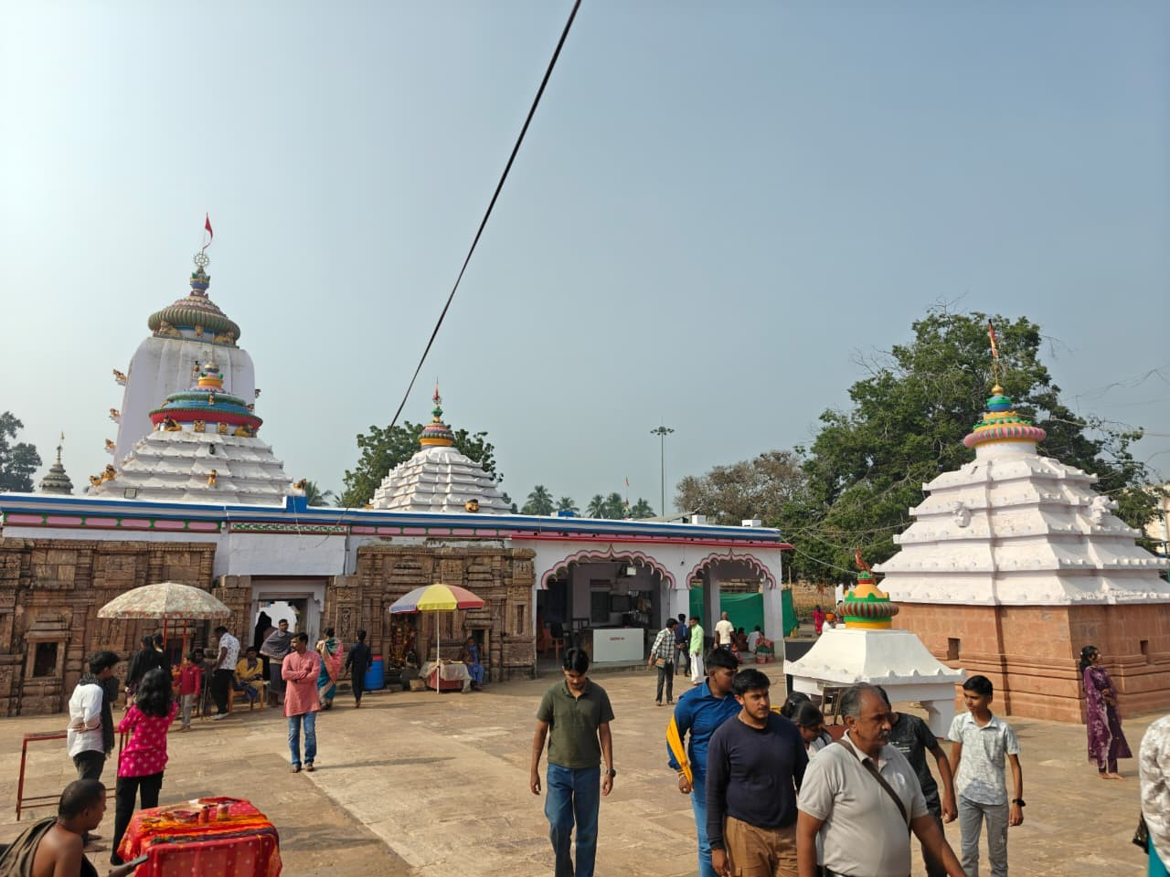

* 1. 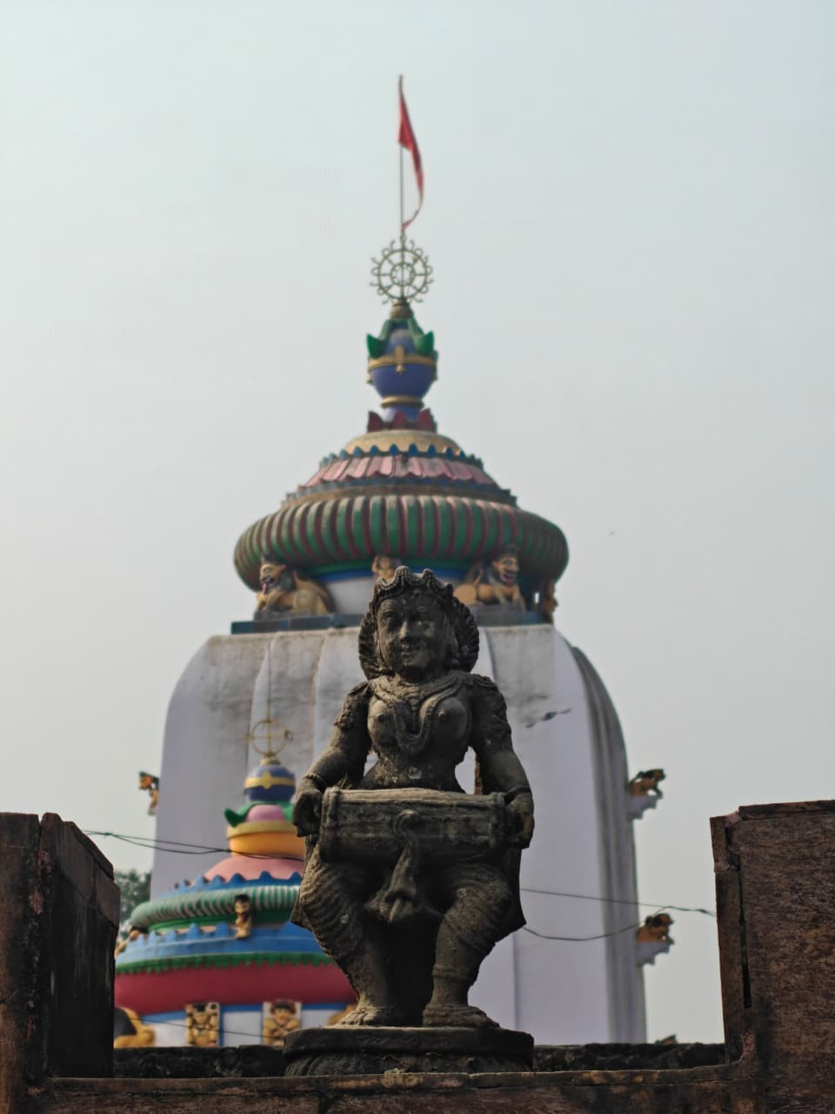
  2. After a great hunt found a pure veg restaurant rayata haveli a grand haveli turned too a restaurant. At 3:00pm.
  3. The Battlefield Within: A Pilgrim's Reflection at Chattia Bata
     1. The clock struck a quarter to five, the hour when the harsh light of day begins to surrender to the softening gold of evening. We arrived at Chattia Bata as tourists, blind in our curiosity, walking circles in a sanctity we did not yet understand.
     2. The stone spoke a language of silence until the guide appeared—the seventh descendant of the saint Sri Hadidas. He was not merely a narrator; he was a key, unlocking the heavy doors of perception.
     3. At the threshold, the temple demanded a shedding of skin. We were greeted not by gods, but by mortals carved in the fever of intimacy—two couples locked in the embrace of Maya.
     4. It was a stark, stone commandment: Leave the hunger of the flesh here. To see the Divine, you must first step out of the seductive shadow of the senses.
     5. We crossed the boundary into the realm of the non-dual. To our right stood the Ardhanareeshwara, the impossible, perfect union of Shiva and Shakti.
     6. The idol defied our binary expectations—a mustache of rugged power coexisting with the delicate nose ring of feminine grace. Here was the Creator as the great Witness, observing the fitness of the soul, waiting to see if we were worthy of the coming Avatar.
     7. But it was the shrine of Lord Kalki that stripped us bare.  
        We descended the steps seeking a face, but the idol offered only a riddle—the left side of a form, half-arms, a horse, a void.
     8. It was a fragment waiting for wholeness. We moved around it, and suddenly, we were not looking at a statue; we were staring into a mirror.  
        And there, in the reflection, the truth manifested. A beautiful white face, eyes vast and liquid, mounted upon a white horse, Lord Balarama as Kalki, sword in hand. The arrangement was a terrifying stroke of genius.
     9. Lord Kalki faces the mirror so that when we approach Him, He is already looking back at us.
     10. We, the pilgrims, wear a million masks—masks of piety, of success, of identity—but the mirror does not blink. It sees the rot beneath the paint. It sees the Maya that corrupts the heart.
     11. The guide spoke then of the geography of war, a philosophy that chilled the blood. In Satya Yuga, the war was between two worlds. In Treta, it shrank to two countries. In Dwapara, it was a fratricide within a family. But now, in the iron age of Kali Yuga, the battlefield has contracted to its final, most dangerous frontier: the human mind. The sword of Kalki is not meant for a tyrant on a throne; it is meant for the tyrant in the mirror. The war is within.  
         We stood before the Adi Bargad, the primal Banyan tree, an ancient witness that stood when Brahma was but a speck in the void. It felt less like a tree and more like an elevator of souls, the mystic junction between the heavy earth of Bhuloka and the ethereal Swarga.  
         Ascending the steps, the pantheon unfolded like a map of consciousness. Lord Jagannath sat in the stillness of Buddha-form, flanked by Balabhadra and Subhadra. We saw the duality of the Divine Mother—Gruha Lakshmi with tongs in hand, the fire that cooks and cares, standing in counterpoint to Mother Durga. Durga smiled, warm and welcoming, yet her hand gripped the trident. The lesson was etched in the air: Love is nourishment, but Love is also protection. There is no safety without strength.  
         This truth culminated in the vision of Maha Kali. She stood in her Rudra Rupa, one foot upon the chest of Shiva. It was a frozen moment of cosmic physics—the transition of rage into calm. We realized that peace is not merely the absence of conflict; often, peace is the result of a war won. Kali’s rage was necessary to devour the evil of Mahishasura, but without the consciousness of Shiva to ground her, that energy would have unmade the world. Emotions are like nuclear fire; controlled, they illuminate. Unchecked, they incinerate.  
         The shadows grew longer as we learned of the cosmic bureaucracy. Lord Yama, the keeper of death, and his scribe Chitragupta, facing south to catch the whispers of the sun and moon. We are watched, the guide reminded us. The sun that warms our skin and the moon that cools our brow are spies, transmitting our deeds to the ledger of the afterlife.  
         We ended our journey at the root—the ancient Radha Krishna deity, the very stone worshipped by Sri Hadidas. The Saligram bore the hood of a snake, a reminder of the coiled energy that lies dormant in all things.  
         As we departed, a final warning hung in the twilight air, sharp as a blade. The path of the Sadhu is fraught with peril. The world must beware of the false saint, the charlatan in saffron robes. But the saint must also beware of the world. Knowledge is power, and power corrupted is a curse that recoils upon the user.  
         We walked out of Chattia Bata different than we entered. We had come looking for idols, but we left carrying a mirror, acutely aware that the final battle of the Kali Yuga was being fought not in the sky, but in the silence of our own thoughts.
  4. 930 raja rani temple
     1. 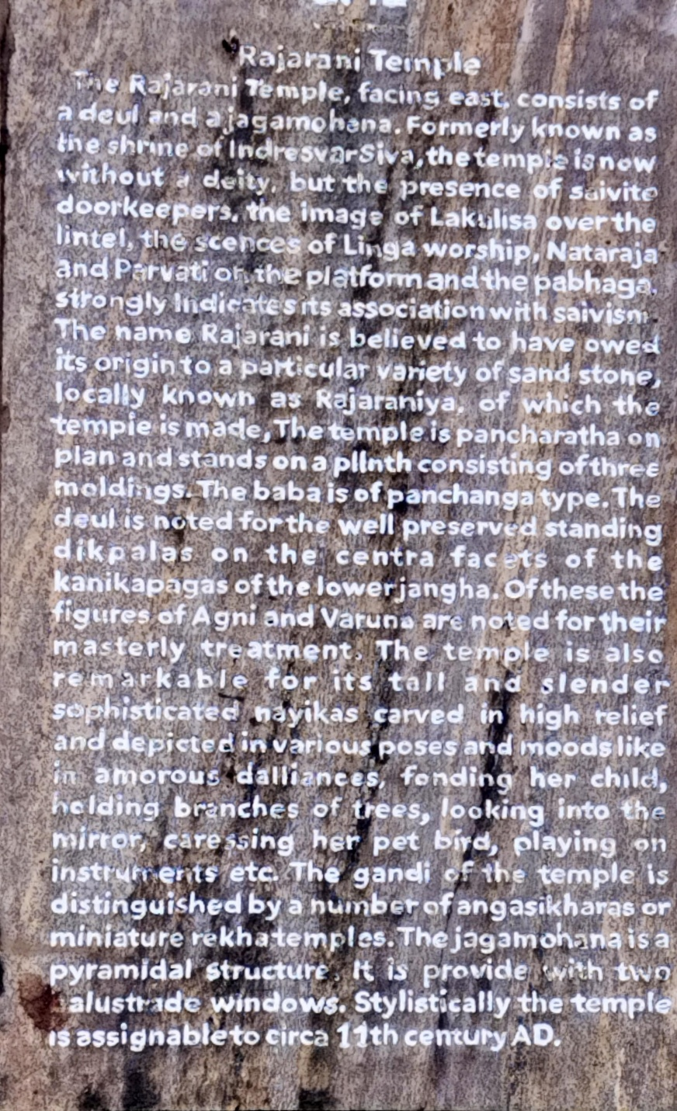

* 1. 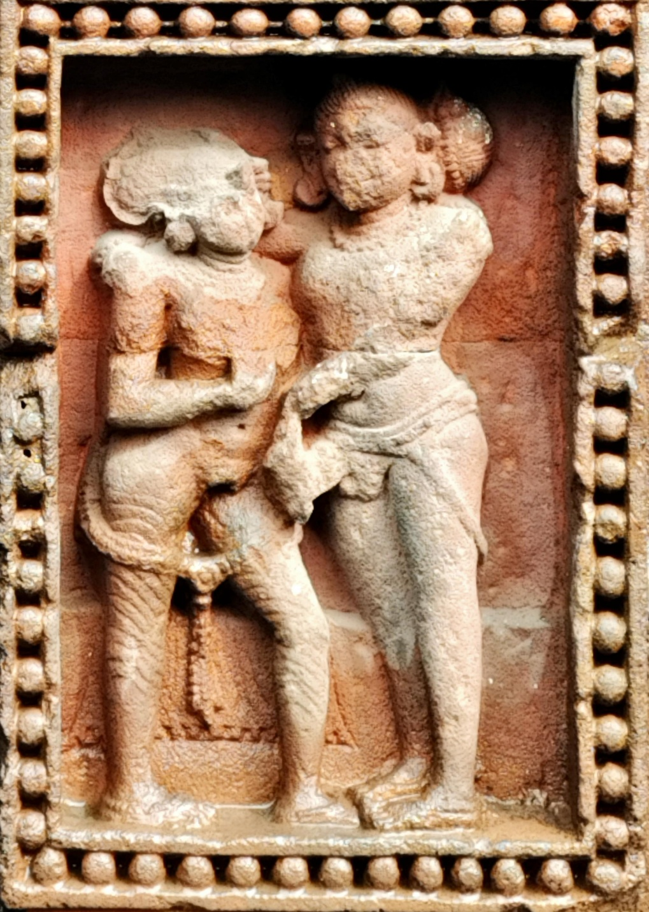
  2. 1015 chaisathi yogini mandir
     1. 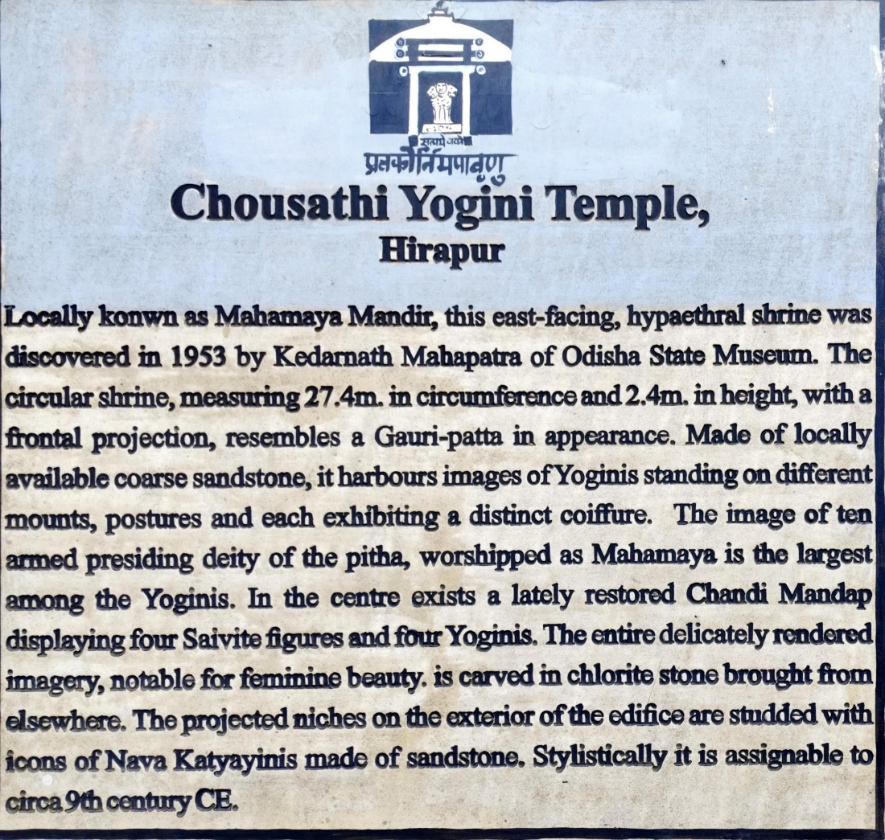
  3. 11 am shanthi sthupa insert story history sthala purana etc.
  4. Reached Konark at 0120 pm.
     1. 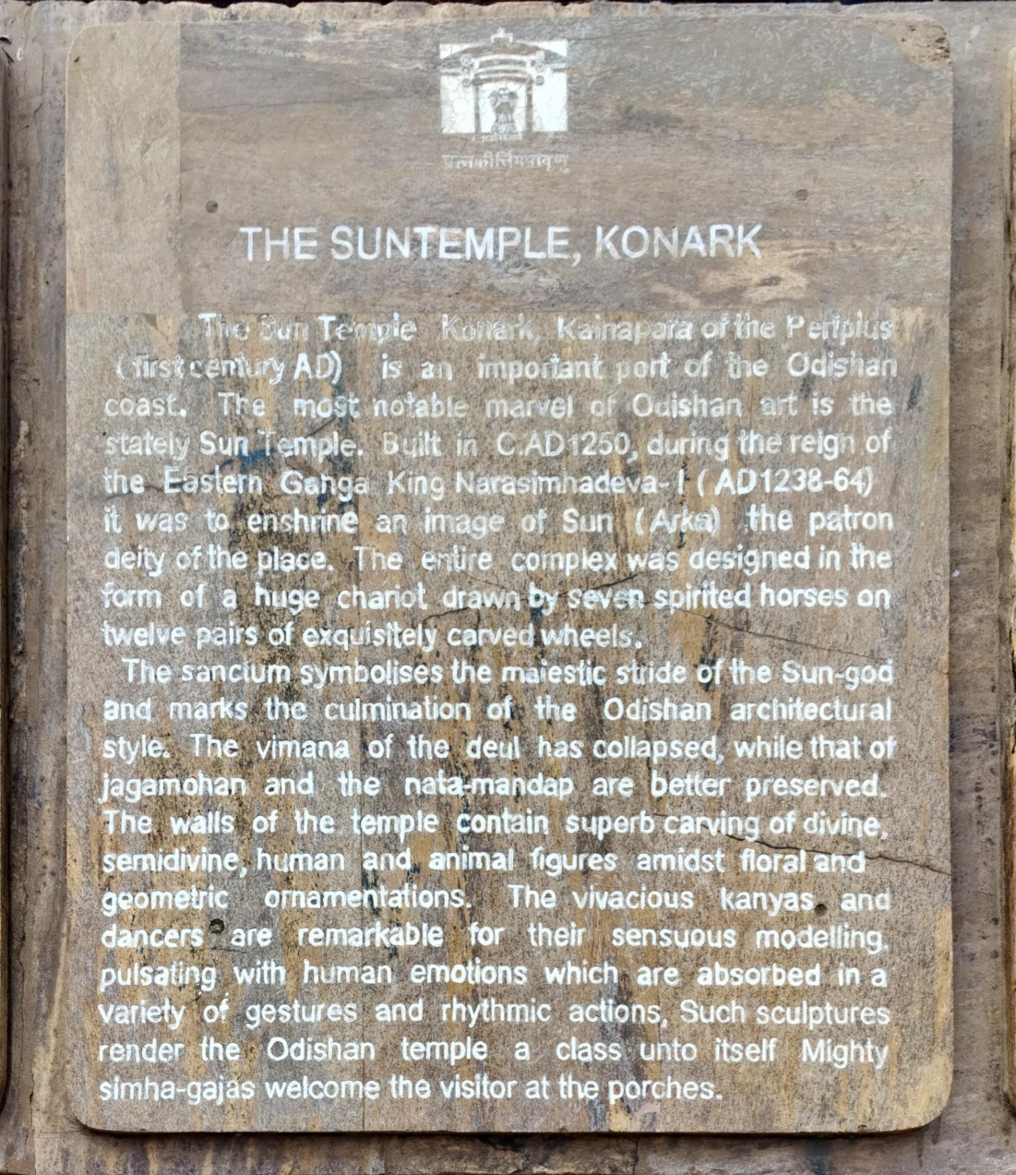

* 1. 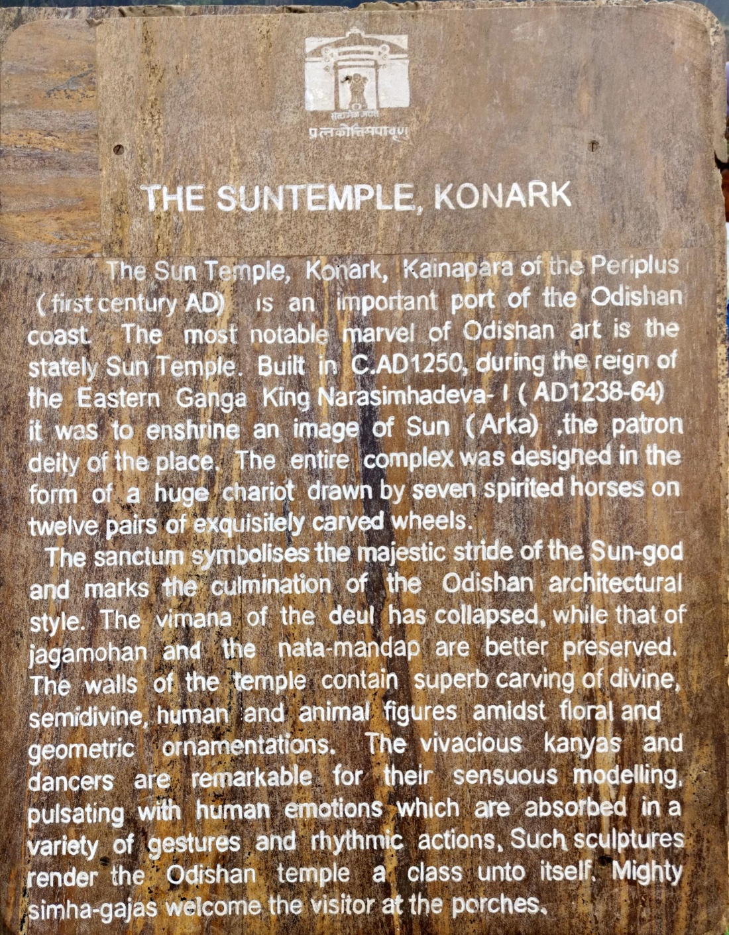
  2. Left at 320
  3. On the way to Puri Jagannath...
  4. Below are the sequence of events and coincidencs that lead to the best darshan ever...
     1. In shubhash Chandra Bose musium we met a group of tourists from Bangladesh.
     2. They approached us to talk and during this conversation we got a contact info of a pandit in Puri Jagannath temple.
     3. We didn't have much hope and then the next day we went to Puri Jagannath temple and the number of devotees were huge. It would have taken us atleast 5 to 6 hours to see the lord.
     4. And hopelessly we called the number we had recieved the previous day. It rang for a while and every ring we were feeling more and more hopeless. Then we heard a voice on the other end and we requested him to guide us and we exchanged the location details and he sent us a young pundit to get us through and then we met him.
     5. He guided us through the gullies that looked like it was taking you back in time and took us to an office where we deposited out mobile phones so we can about the waiting time for depositing.
     6. As the flag change was happening we were running through the crowd to reach the west gate the tiger gate. Then we stood in the VIP queue for 20 mins and we entered the temple complex there too the number of devotees were unimaginable. Research and insert all the deities in the temple complex with back stories and make it feels like a walk through.
     7. Inside also we were guided to hanumanji to ask his blessings and then we swiftly navigated through the crowd and we stood in the queue and the first sight we had was of bhalabadra jis beautiful white face, the. Subhadra ma and then the king himself lord Jagannath.
     8. As soon as we saw him we were shoved close to the left wall so we can see lord Jagannath to the hearts content we stood there for about 5 minute uninterrupted while the sea of devotees were being shoved out of the main temple.
     9. Then we were guided out to visit other Temples around and main temple and were strictly told not to give dhana for anything because we are smaller than the lord and dhaan is given to someone smaller and lord Jagannath is the lord but he told in the end of the dharshan we can give dhan for annaprashan and that's what we did.
     10. Just out of curiosity we asked pandit ji on if we can get some prasad in the temple complex, and to my surprise he asked us to sit down right were we were did our donation and in am instant we got 5 plates of prasad.
     11. The maha Prasad was totally un believable there is no way to put it in word. Insert about maha Prasad.
     12. Later we were guided out where we were asked to watch our steps to not step on yama stone as stepping on it will remove all the benifits we gained by visiting.
         1. Make this feel like a guided walkthrough i have left out many stories many temples and many gods make sure too add everything with purana stories direction location etc.
     13. After this we went back to the pandit jis office and collected the phones and gave him a dakshina for the best possible darshan ever.
         1. (this whole trip was full of coincidence and luck we were able to see many temples just in time right when the temple was about to close we entered or if I did not ask a question to sri Hadidas we would not know about kalki if we didn't jump the fence we wouldn't be abled to see the jain temple, if we were not heard speaking on kannada then the Bangalore tourists would not have met atall and we would have never got any contact and later we would have to spend alot of time or money for a darshan. Now looking at this journey or it feels Lord Krishna wanted to see me so he called me and then the whole trip was so safe so comfortable as if the lord himself was overseeing the whole journey.